Cardio Oncology Symposium Africa

In spite of the outbreak of the Coronavirus, the first cardio oncology conference on the
African continent prospered in Durban, South Africa, on March 7, 2020. Organized by ICOS
Executive Committee member, Dr. Trishun Singh, nearly 100 participants from across Africa
gathered for the genesis of cardio oncology training on this beautiful land mass of more
than 1.2 billion people.
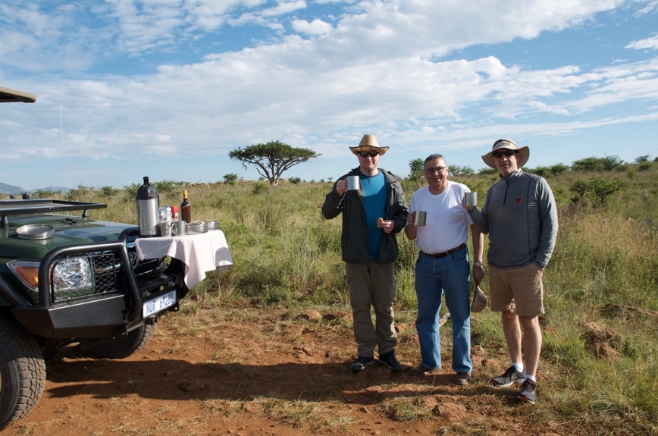
Figure 1 Dr. Sebastian Szmit, Dr. Trishun Singh, Dr. Steve Casselli
Dr. Singh has been involved in cardio oncology since 2015 and established the first cardio
oncology center in Africa at uMhlanga hospital in Durban. Along with his colleagues – Dr. Ria
David, the only medical oncologist in the province of KwaZulu-Natal, and Ines Buccimazza, a
breast cancer surgeon – they established the Cardio Oncology Society of Southern Africa
(COSOSA) in 2019.

The conference began with a presentation from the President of ICOS, Dr. Daniel Lenihan,
by way of video conference. Dr. Lenihan set the stage for all who followed, presenting a
brief overview of the history of the cardio oncology movement. An outstanding example of
a multidisciplinary course, the program included presentations on imaging, radiotherapy,
bioethics, Amyloidosis, immunotherapies and cancer survivorship. Dr. Sebastian Szmit,
President of ICOS Poland, attending in person, presented a lecture on the “Cardio Oncology
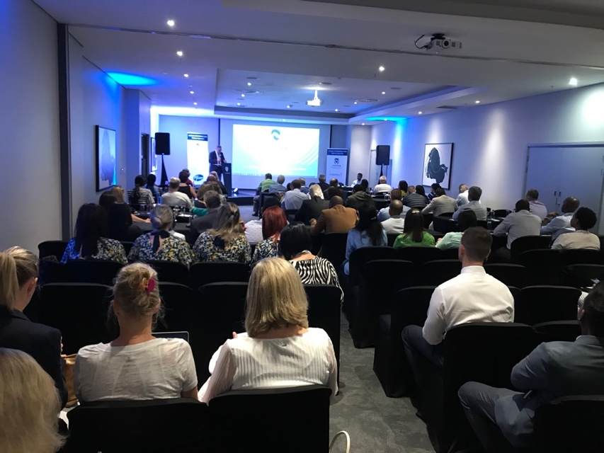
Effects of Renal Carcinoma and Lymphoma Treatment.” Dr. Szmit and Dr. Ria David moderated a quiz which provoked lively and fruitful debate among the delegates. Dr. Eric Harrison, Chairman of the Board for ICOS, closed the conference with another video conference addressing the issue of survivorship and heart health.
Figure 2 Dr. Trishun Singh opens the conference

As is true in every country, South Africa faces unique challenges. There are only 200
oncologists and even fewer cardiologists in a country of nearly 60 million people. Thus, the
demands placed upon those involved in cardio oncology are extraordinary. In addition to
the limited number of physicians, 9-10% of the population suffers from diabetes, an
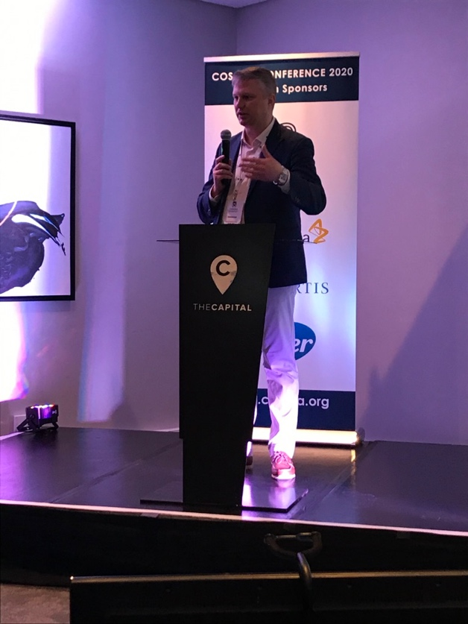
important comorbidity relative to some cancers and all heart disease. It is also estimated that more than 5 million people in South Africa live with HIV. These challenges, however, provide special opportunities for novel research and treatment programs to develop. As innovative approaches are created, new insights emerge that will be of benefit to other countries around the world.
Figure 3 Dr. Sebastian Szmit

The organizers of COSOSA can be satisfied and proud of their launch. It will be difficult to
match the quality of their inaugural event, but it’s time to start preparing for the second
annual conference. Congratulations COSOSA!

