Cardio-Oncology – Clinical Faculty
Rush University Medical Center
Chicago, IL

Rush University Cancer Center and the Division of Cardiology at Rush University Medical Center is seeking a board-certified Cardio-Oncologist to join their team. The cardio-oncology program at Rush is a comprehensive program that includes ambulatory patient care with a team of RN and Advanced Practice Provider, inpatient general cardiology and cardio-oncology consult services, cardiovascular imaging, clinical and translational research, and being involved in various cardio-oncology projects including the Chicago city-wide cardio-oncology rounds, the regional Biennial cardio-oncology symposium, the biannual cardio-oncology patient education series, and the cardio-oncology case rounds geared toward educating cardiovascular and oncology providers and trainees on topics in cardio-oncology. This position offers a competitive salary, comprehensive benefits and an academic appointment in the Department of Internal Medicine, Division of Cardiology, commensurate with experience; as well as the opportunity to flourish and become a thought leader in cardio-oncology.

Rush has specialists devoted to diagnosing and treating virtually every type of heart problem in adults. Comprehensive care for treating and preventing heart disease includes: General cardiology services, Chicago’s first dedicated center for women’s heart care, early detection and screening programs, outpatient chest pain center, advanced techniques in cardiovascular and thoracic surgery, a state-of-the-art interventional cardiology program for noninvasive cardiology services, comprehensive electrophysiology with arrhythmia and pacemaker services, adult congenital, cardiooncology, cardionutrition, cardiometabolic clinic, cardiorheumatology and specialized treatment and follow-up care for people at all stages of heart failure and its complication and clinical research, evaluating new medicines, devices and procedures in heart care. Rush heart patients benefit from the availability of the most advanced diagnostic techniques in heart care today.
Rush University System for Health is an academic health system whose mission is to improve the health of the individuals and the diverse communities it serves through the integration of outstanding patient care, education, research and community partnerships. Rush includes Rush University Medical Center, Rush University, Rush Copley Medical Center and Rush Oak Park Hospital, as well as numerous outpatient care facilities. Rush University, with more than 2,500 students, is a health sciences university that comprises Rush Medical College, the College of Nursing, the College of Health Sciences and the Graduate College. Rush University Medical Center is an elite medical community recognized for excellence in patient care, medical discovery and clinical expertise. Our continued pursuits have earned Rush University Medical Center the distinction of being on U.S. News & World Report’s Best Hospitals Honor Roll for 2021-2022. This places the Medical Center among the top 20 of the 3,000 hospitals evaluated. U.S. News & World Report has also recognized nine Rush programs among the nation’s best, including top 10 national rankings for neurology and neurosurgery and orthopedics. These accolades, along with many others that include a decade of Magnet® designation, reflect the collective efforts and commitment to excellence demonstrated by our physicians, advanced practitioners, nurses and medical staff. Rush University Medical Center has received Vizient's Quality Leadership Award, ranking first among 99 academic medical centers across the country. All three Rush University System for Health hospitals have earned the LGBTQ Healthcare Equality Leader designation in the Healthcare Equality Index.

Interested candidates, please send your CV and cover letter to:

Rose Sprinkle
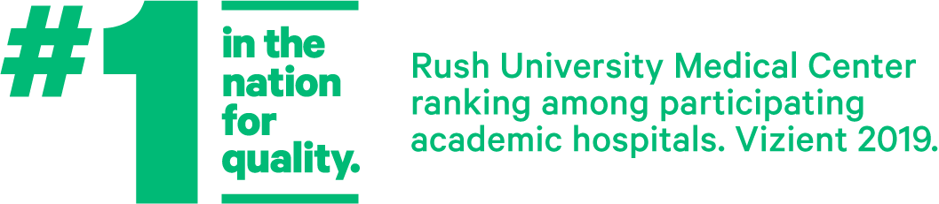
Senior Director, Faculty Recruitment
Faculty_Recruitment@Rush.edu
Rush is an equal opportunity / Affirmative Action employer

